Responses to Reviewer Comments
Reviewer comments are in bold, our responses are in italic blue font, and relevant excerpted texts are highlighted in yellow with new/revised figures copied inline.
Referee: 1
Comments to the Author
The manuscript by Wang et al describes the development and testing of a low-cost and fully automated system for fractionation of flow-chemistry. It is an extremely clever and useful system that incorporates low-cost components along with elegant engineering. Given that this work is accompanied by a complete github page with full documentation, this type of work substantially lowers the barrier to entry for automating flow-chemistry systems. I support publication once the authors address the following comments:
Response: We thank the reviewer for the thoughtful feedback. We have carefully addressed all comments to improve the quality and clarity of the manuscript.
(1) In the introduction it is stated that this platform is accurate and precise. These are words with specific meanings and it would be beneficial if the authors could put numbers to these claims. If meaningful comparison can be found, it would be useful to compare these numbers against commercial standards.
Response: We thank the reviewer for pointing this out. We agree that the terms accuracy and precision have specific scientific meanings, and we have revised the wording accordingly to avoid potential ambiguity. In the revised Introduction, we now quantify the repeatability of the system by reporting the coefficient of variation (CV) of the fitted drop mass across replicate experiments under all tested flow conditions, which was found to be 1.3%. While commercial fraction collectors do not typically report repeatability in terms of CV, comparable liquid handling systems (e.g., calibrated pipettes and automated dispensers) commonly exhibit repeatability on the order of ~0.3–2%, depending on volume and operating conditions.
The fraction collector features a drop counter for independent control of each fraction's volume and a compact form factor that can be easily integrated into a standard chemistry fume cupboard. It also provides real-time feedback on dispensed volume, enabling reliable droplet detection and reproducible collection regardless of pump calibration or flow irregularities. Across replicate experiments, the system achieved a coefficient of variation (CV) of 1.3% in the fitted drop mass, indicating high precision and repeatability. The collector ensures clean separations between samples and can be customised for diverse laboratory setups. Page 2-3
(2) While I found figure 3 to display an impressive level of consistency across a wide range of viscosities, I would not expect the drop volume to depend on viscosity in the quasi-static limit where drop breakoff is a competition between gravity and surface tension. In this case, I would expect different fluids or even the same fluid with different additives could behave very differently. For instance, a low surface energy solvent like toluene will behave very differently from a high surface energy one like ethanol. Discussion should be added about how this affects the measurements and how any variations due to this effect can be compensated.
Response: We thank the reviewer for this insightful comment. We agree that, in the quasi-static regime, droplet breakoff is governed primarily by the balance between gravity and surface tension, so droplet volume is not expected to depend on viscosity alone. To address this point, we have added discussion in the revised manuscript clarifying that the variation observed between fluids is consistent with the expected influence of interfacial properties. We further clarify that the system does not rely on a universal fixed droplet volume across all fluids. Instead, effective drop mass can be determined empirically and calibrated when needed, for example by gravimetric reference measurements for fluids with more extreme interfacial behaviour.
The observed variance between fluids may be influenced by factors including pump compliance, fluid density, viscosity, and interfacial properties.^{26,27} In the present study, the relatively larger deviation observed for the 1 cP standard is consistent with its lower density compared with the other Siltech viscosity standards used, which otherwise have more similar densities across the higher-viscosity range. It was also qualitatively observed that higher viscosity fluids sometimes exhibited pulsation issues and reduced flow rates, likely due to increased backpressure and mechanical limitations of the pumping system. In the quasi-static regime, droplet detachment is governed primarily by the balance between gravity and surface tension, and therefore droplet size is expected to depend on fluid properties such as surface tension and wetting behaviour rather than viscosity alone.^{28–30} As a result, different solvents or additives may yield different droplet volumes under otherwise identical conditions. The system does not assume a fixed droplet volume across fluids, as the effective drop mass can be empirically determined and, if needed, calibrated using reference measurements (e.g., gravimetric analysis) for fluids with more extreme interfacial properties. Overall, the results suggest that the fraction collector is compatible with a broad range of liquids, including fluids more viscous than typical organic reaction mixtures, and can support practical volume-based fraction collection across diverse flow-chemistry conditions while allowing fluid-specific calibration when needed. Page 7
(3) While the discussion of CNC machines for low-cost lab automation had the right spirit, I felt that reference 10.1016/j.ohx.2024.e00601 should be included as it uses exactly this CNC machine and even does so in conjunction with a Vernier sensor, which bears mention as these systems are often educational products and not commonly used for research. Also, it seemed strange to claim that reference 20 built on the utility of tools like the one described in reference 19 when reference 20 was published about a year before reference 19. Finally, reference should be made to Jubilee (i.e. 10.1145/3313831.3376425) which is an early gantry-based system for research.
Response: We thank the reviewer for this helpful suggestion. We have added the recommended references, including the work reported in 10.1016/j.ohx.2024.e00601 and the Jubilee platform (10.1145/3313831.3376425). In addition, we corrected the wording surrounding References 19 and 20 to remove the implication that one study built on the other.
Computer numerical control (CNC) machines, which use a precise XYZ gantry to move an integrated toolhead, have been repurposed to hold research tools for low-cost lab automation.^{22–25} For example, Monterrubio et al.²² designed a CNC-based liquid handler to enhance the reproducibility and throughput of inorganic materials synthesis. Similarly, Quinn et al.²³ integrated liquid handling with electrochemical and optical characterisation to perform closed-loop exploration of functional polymer films. Page 2
(4) The authors describe an experiment that involves a microtiter plate. It would be useful to see a photograph of how the system looks in this configuration.
Response: We thank the reviewer for this suggestion. To better illustrate the system configuration used in the experiment, we have revised Figure 1 and ToC to include the microtiter plate along with a waste beaker in the rendered setup.
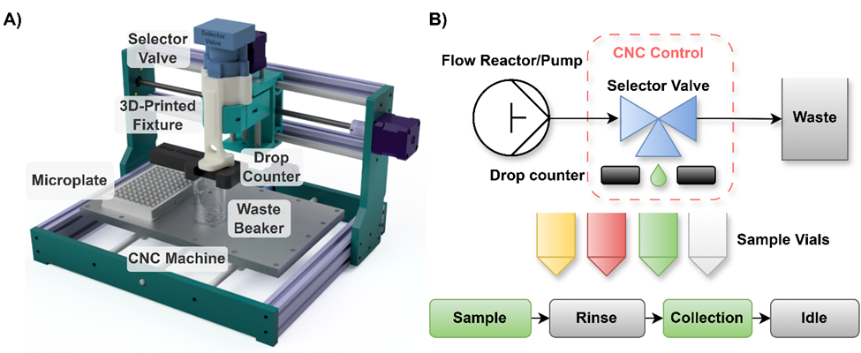 Figure 1, Page 5
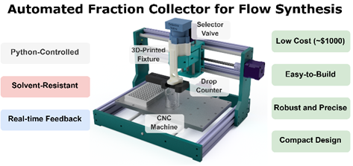ToC, Page 1
Referee: 2
Comments to the Author
This manuscript reports a low-cost, Python-controlled fraction collector capable of real-time, volume-based sampling in continuous-flow chemistry setups. The authors employ a modular design and software control to achieve high-precision monitoring of droplet volumes. System performance is thoroughly validated through droplet weight measurements, flow rate and viscosity testing, visual dye separation, and quantitative NMR analysis of an organic reaction. These experiments convincingly demonstrate the collector’s accuracy, reproducibility, and applicability. I have a few questions and suggestions that should be addressed to strengthen the manuscript:
Response: We thank the reviewer for the thoughtful summary. We have carefully addressed the comments and answered the questions to further strengthen the manuscript.
1. In the flow reaction examples provided, as well as in other continuous-flow reactions, how is steady-state operation determined? Is it simply based on pre-running a segment of the reaction stream, or are more quantitative metrics used?
Response: We thank the reviewer for this question. In the flow reaction examples presented in this work, steady-state operation was determined from the reaction profile generated by the Vapourtec flow reactor rather than by simply discarding a fixed pre-run volume. Specifically, the code extracted the reaction timing profile and automatically calculated when the outlet stream should be directed to waste and when fractions should be collected. Three fractions were collected during the steady-state period, while the pre-steady-state and post-steady-state portions were discarded to waste. A buffer factor was also included in the collection logic to provide an additional margin of confidence that only steady-state product was collected.
All of these steps were automated in the control code provided in the GitHub repository. At the time of the experiments reported here, steady-state identification was therefore based on the programmed reaction profile and timing calculations. In our current setup, we have further extended this capability by integrating the Vapourtec API, which enables real-time feedback and more precise determination of when to begin and end collection. We expect this to further improve the robustness of fraction collection, and the codebase will continue to be updated and maintained for broader community use.
2. In a typical steady-state reaction, the effluent contains a mixture of target product, unreacted starting materials, catalyst, solvent, and side products. Therefore, what is the specific rationale for performing fraction collection in this study?
Response: We thank the reviewer for this important question. We agree that, in a typical steady-state flow reaction, the collected effluent is generally still a multicomponent mixture containing product, solvent, residual starting materials, catalyst, and possible side products. Accordingly, the purpose of fraction collection in this work is not direct purification, but rather the automated and reproducible segmentation of the reactor outlet into defined collection windows.
In practical deployment of continuous-flow reactors, the reaction profile may change continuously over time, such that multiple reaction conditions, or even multiple reactions, can in principle be carried out in sequence without human intervention. However, without coordinated downstream handling, these different outlet streams would normally remain disjointed only in time and would ultimately exit through the same outlet, making selective collection difficult and reducing the benefit of automation. The fraction collector addresses this challenge by enabling products generated at different reaction stages, or from different sequential reaction conditions, to be directed into separate collection vessels in an accurate, repeatable, and high-throughput manner.
In the examples presented here, this capability was used to discard pre- and post-steady-state material while selectively collecting fractions corresponding to the desired steady-state window. More broadly, such functionality is particularly important for autonomous or closed-loop workflows in which reaction, characterization, and decision-making are integrated. In these settings, experimental conditions may be updated iteratively by machine learning or active learning algorithms, and real-time or programmatically controlled fraction collection becomes necessary to ensure that the material sent for downstream characterization or analysis corresponds to the intended reaction condition.
3. Beyond viscosity, has the effect of solution density been considered? For example, for solvents like dichloromethane, the mass per droplet would be expected to differ significantly, which may limit the applicability of Figure 3.
Response: We thank the reviewer for this important comment. Solution density was not ignored in our interpretation of Figure 3, and we agree that it can contribute to differences in measured droplet mass. The viscosity standards used in this study were Siltech polydimethylsiloxane fluids, which have reported densities ranging from approximately 0.82 to 0.97 g/mL across the tested set. In particular, the 1 cP standard has a lower density of about 0.82 g/mL, whereas the 50-500 cP standards are all in the range of approximately 0.96-0.97 g/mL. This difference likely contributes to the variation in droplet mass observed for the 1 cP fluid relative to the others, and we have clarified this point in the revised manuscript.
We agree with the reviewer that for liquids with larger density differences, such as dichloromethane relative to many common organic solvents, the mass per droplet would be expected to differ accordingly. However, in most practical flow-chemistry workflows, dosing and collection are fundamentally volume-based rather than mass-based, as upstream handling is typically controlled by pumps, syringes, or other volumetric delivery systems. In this context, variation in droplet mass across fluids is not necessarily detrimental to the intended application of the fraction collector. Rather, the key performance metric is the consistency and repeatability of collection within a given condition, which is what Figure 3 is intended to demonstrate. We have revised the manuscript to better clarify this distinction and to note that fluids with substantially different physical properties may require empirical calibration when higher quantitative accuracy is desired.
The observed variance between fluids may be influenced by factors including pump compliance, fluid density, viscosity, and interfacial properties.^{26,27} In the present study, the relatively larger deviation observed for the 1 cP standard is consistent with its lower density compared with the other Siltech viscosity standards used, which otherwise have more similar densities across the higher-viscosity range. It was also qualitatively observed that higher viscosity fluids sometimes exhibited pulsation issues and reduced flow rates, likely due to increased backpressure and mechanical limitations of the pumping system. In the quasi-static regime, droplet detachment is governed primarily by the balance between gravity and surface tension, and therefore droplet size is expected to depend on fluid properties such as surface tension and wetting behaviour rather than viscosity alone.^{28–30} As a result, different solvents or additives may yield different droplet volumes under otherwise identical conditions. The system does not assume a fixed droplet volume across fluids, as the effective drop mass can be empirically determined and, if needed, calibrated using reference measurements (e.g., gravimetric analysis) for fluids with more extreme interfacial properties. Overall, the results suggest that the fraction collector is compatible with a broad range of liquids, including fluids more viscous than typical organic reaction mixtures, and can support practical volume-based fraction collection across diverse flow-chemistry conditions while allowing fluid-specific calibration when needed. Page 7
4. Regarding the discussion of continuous-flow system applications and reactor context, it is recommended to cite the following relevant literature: Org. Process Res. Dev. 2023, 27, 1198–1202; Org. Process Res. Dev. 2024, 28, 1683–1689; Adv. Sci., 2024, 11, 2403002.
Response: We thank the reviewer for pointing out these relevant studies. In response, we have incorporated the recommended references into the revised Introduction to strengthen the discussion of continuous-flow system applications and reactor context.
Automated chemical synthesis and characterisation platforms often rely on flow-based systems to accelerate research.^{1–3} Unlike traditional batch chemistry, flow-based systems are relatively straightforward to automate, enabling precise, automated tuning of reaction parameters and making them especially advantageous for reactions requiring tight control or hazardous conditions.^{4–8} This has made flow chemistry attractive for organic synthesis, including polymers, macromolecules and pharmaceuticals, as well as automated reaction screening.^{9–13} Page 2

Referee: 3
Comments to the Author
The repository at https://can01.safelinks.protection.outlook.com/?url=https%3A%2F%2Fgithub.com%2FAccelerationConsortium%2FFrac-Collector&data=05%7C02%7Cnipun.gupta%40utoronto.ca%7C64ddf70b30114cb81c8308de7f013dbe%7C78aac2262f034b4d9037b46d56c55210%7C0%7C0%7C639087840516455007%7CUnknown%7CTWFpbGZsb3d8eyJFbXB0eU1hcGkiOnRydWUsIlYiOiIwLjAuMDAwMCIsIlAiOiJXaW4zMiIsIkFOIjoiTWFpbCIsIldUIjoyfQ%3D%3D%7C0%7C%7C%7C&sdata=KUMEOxO2TADjAsk%2FpKy7PVxZOm0X4IRrIG6vg9yavEU%3D&reserved=0 needs updating in order to meet the software reproducibility criteria for the journal. The repository does not include a requirements.txt, setup.py, or pyproject.toml file, which makes determining the build environment very challenging, particularly since the gdx library on PyPI has not been updated for a decade and that package's interface does not appear to conform to the package's usage.
Response: We thank the reviewer for pointing this out. We agree that the repository should more clearly specify the software environment. We have updated the GitHub repository to include both a requirements.txt file and a pyproject.toml file to enhance the reproducibility and deployment of the system.

